
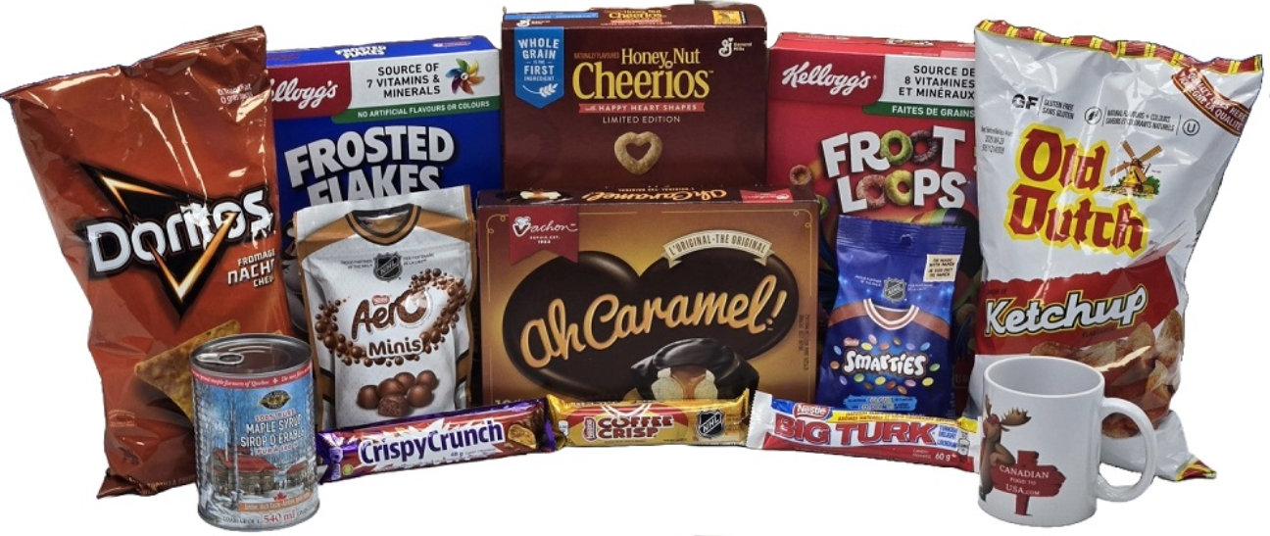
Local Business Offers Canadian Expats a Taste of Home and its not just maple syrup

ADMIN AUGUST 10, 2025 2 MINS READ

There are a few million Canadians permanently living and working in the United States and many of them miss some of the tastes of home they were used to finding on grocery shelves back home. CanadianFoodtoUsa.com is an online Ecommerce business based in Hamilton, Ontario that has given their fellow Canadians an opportunity to purchase those missed food products from their website, as well as some fun merchandise and souvenirs.

Originally launched in 1999 as CanadianFavourites.com, the idea for the business was sparked when one of the current owners who was living in Florida at the time, was missing his Strub’s pickles and Tim Hortons coffee and asked a family member to send them. As one of the owners said “We felt that if I was missing some of my favourite foods, there must be many
more like me who are feeling the same way”. It grew quickly through word of mouth, support from Canadian clubs and organizations, and media coverage. Customers included Canadian embassies, celebrities, film sets around the world, and to the surprise of the owners, many Americans.

That original business sold in 2008, but was started up again during the pandemic with a name change and an even larger selection. Their customers have helped build the site through product requests and suggestions for merchandise as well as food items. Some of the original customers from the first business have discovered them again. “It’s been a lot of fun reconnecting and catching up after all these years and they are still ordering the same products!”

Currently there are over 900 products listed on the website including chocolate, chips, the bakery, cereal, sauces, jams, beverages, and more. All products sell but all-dressed and ketchup chips, chocolate, cereal, and cookies top the list. And who knew Dempster’s Malt Bread was so popular! The list of products that are uniquely Canadian includes Butter Tarts, Nanaimo Bars, Poutine, Smarties, Coffee Crisp and Aero chocolates, Jos Louis, Wine Gums, Hawkins Cheezies, Hickory Sticks, and of course the holy grail of Canadian snacks – ketchup chips from all the major brands! One of the blogs on their website describes the differences between Canadian and American chocolate.

Although the business started to serve Canadian expats in the US,, the business has many American customers (“Who we love to hear from and who have been very supportive”) who have perhaps visited Canada and sampled a particular food item or beverage only to discover it isn’t available in the States. “Our coffee and candy is very popular with Americans as are some of our cereals which don’t contain certain additives and dyes found in the American counterpart”

Canadian Food To USA is registered with the FDA and shipping has been seamless even with all the current tariff talk. These products are protected under CUSMA.

“We really enjoy what we do and although it can be a lot of work,” says owner Ian White, “ it’s great to connect with Canadians and our American customers every day and to hear their stories”

They can be reached at info@CanadianFoodToUsa.com

